**Object Tracking**

In this project I created a program for object tracking. you use the mouse to define an object and then track it using MOSSE method from OpenCV module.

when a P button is pressed, the video is paused and the last two frames are displayed overlayed on the left side. on the right side also an overlay of the same two frames are displayed, but after shifting one frame to adjust the motion in order to cancel the difference between the frames.

In the picture below you can see an example:

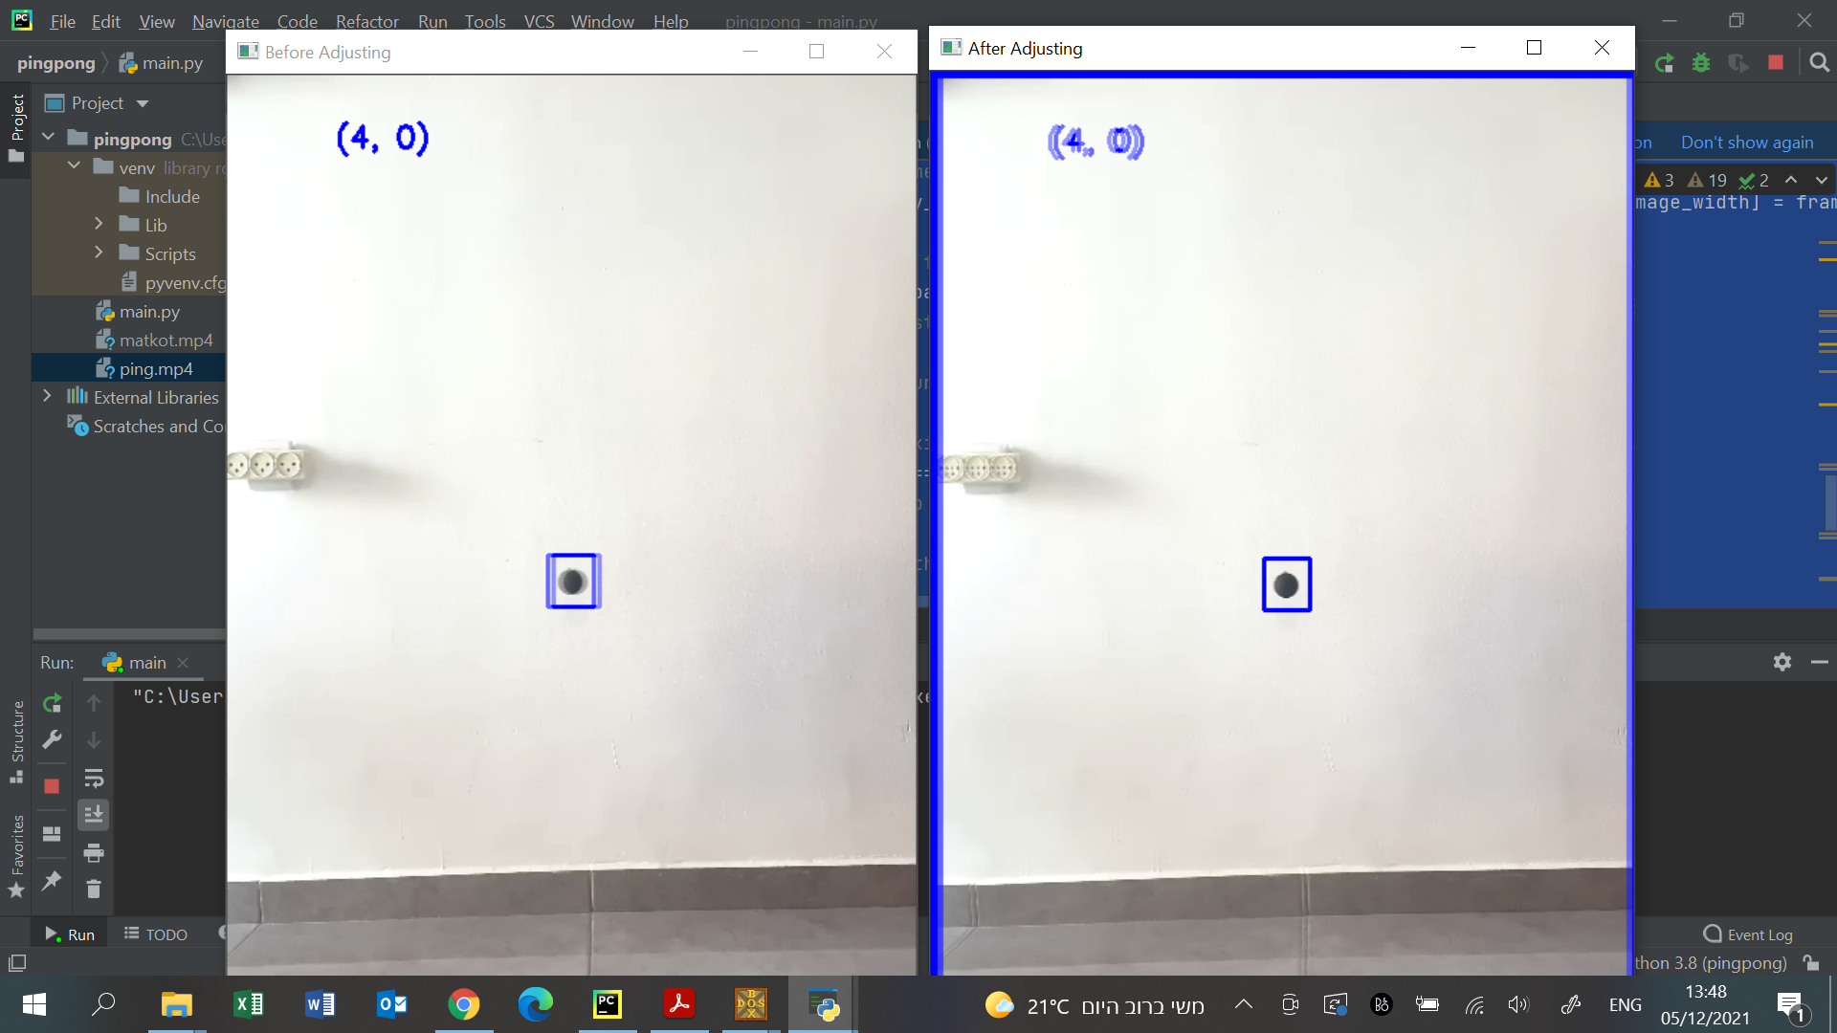

The fact that on the left the object is looks blurred but the background is clear and on the right it is the opposite proves that the shifting was made right.

I chose the MOSSE tracker (Minimum Output Sum of Squared Error) because it enables a good balance between accuracy and speed and is robust to variations in lighting, scale, pose and non-rigid deformations.